COMPUTER PROJECT

OUTPUTS OF BOTANICAL GARDEN

1. DATABASE AND TABLES IN BOTANICAL GARDEN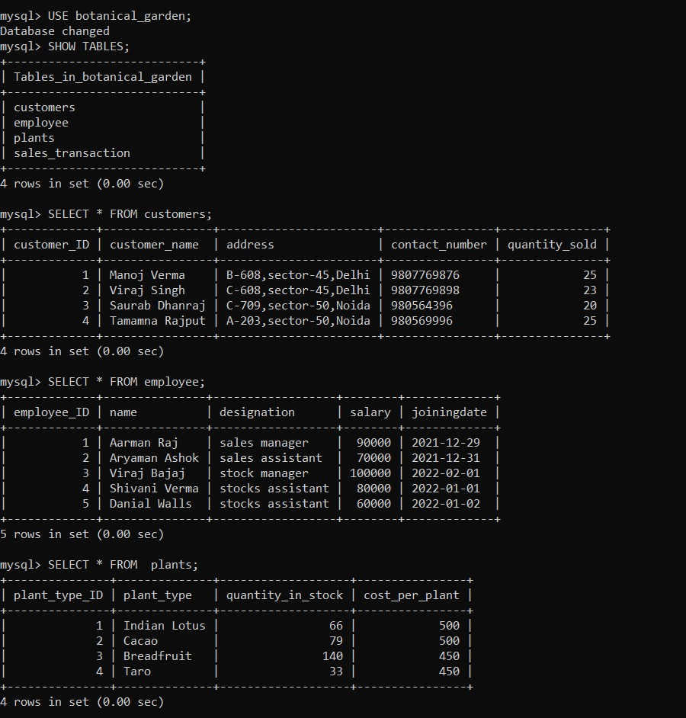

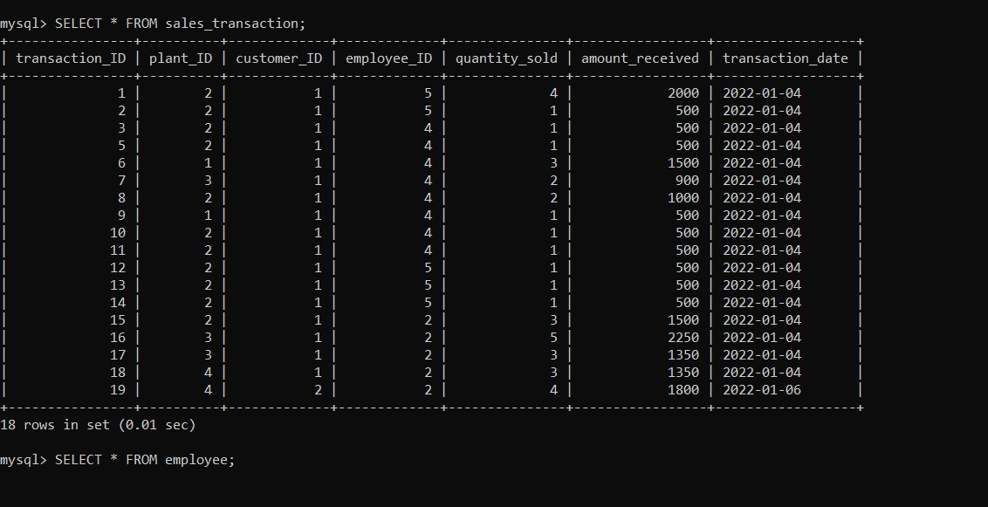

2. LOGIN PAGE

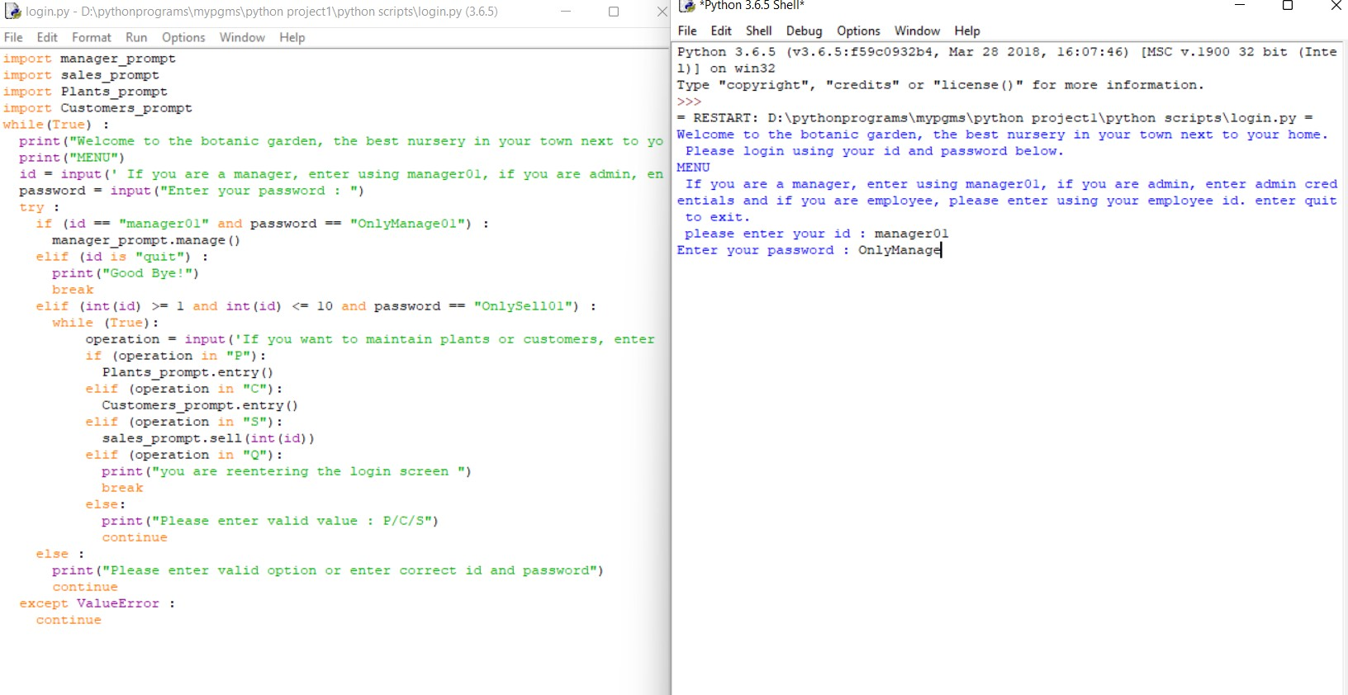

2. Manager’s login (manager_prompt)

Part 1 – Adding a new employee

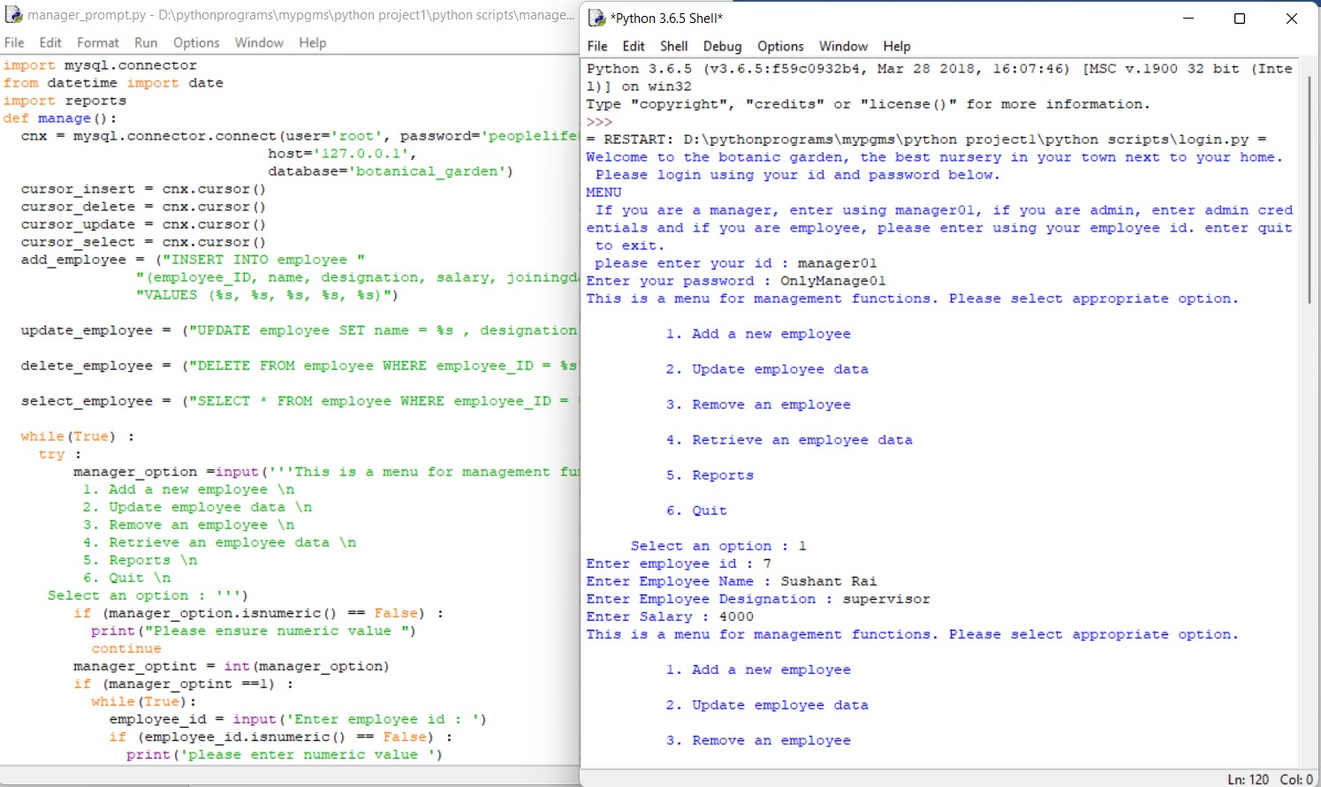

Part 2 – Updating employee data and Part 3 – Removing data of an employee

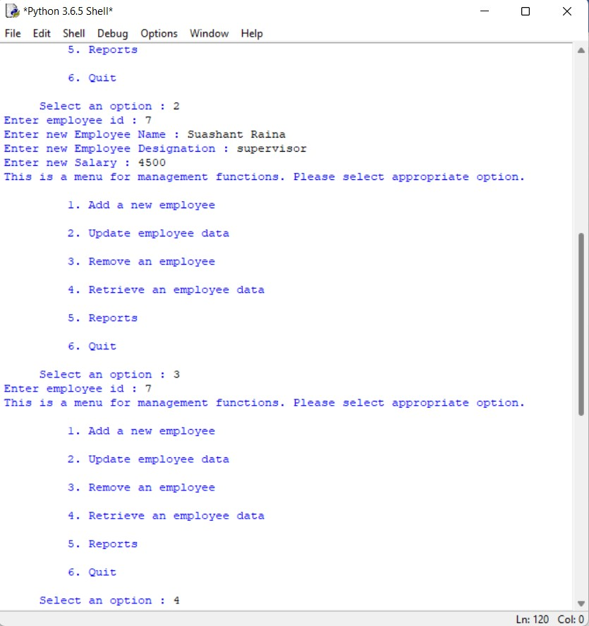

Part 4 – Retrieving an employee data and Part 5 – Reports

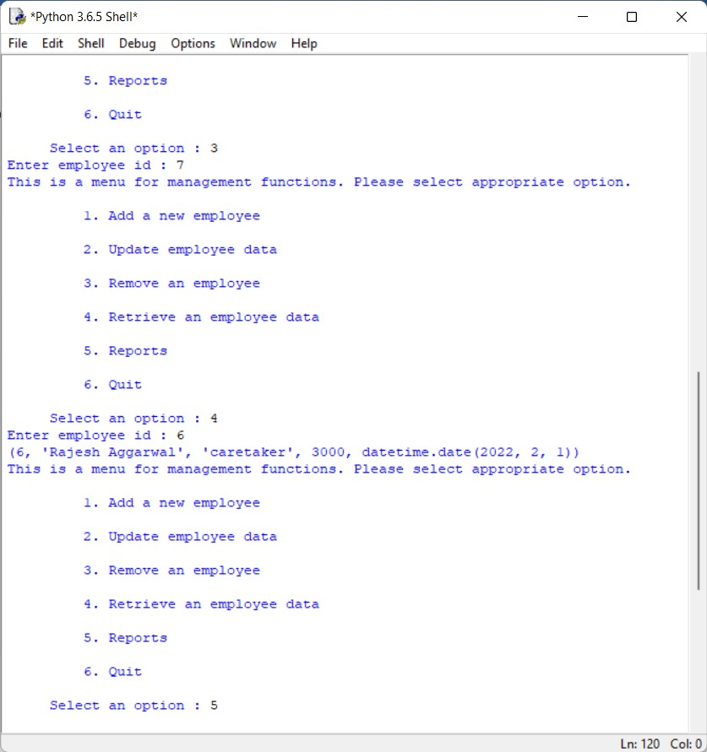

Option 5 enables the manager to view the reports of employees, accessing the reports module.

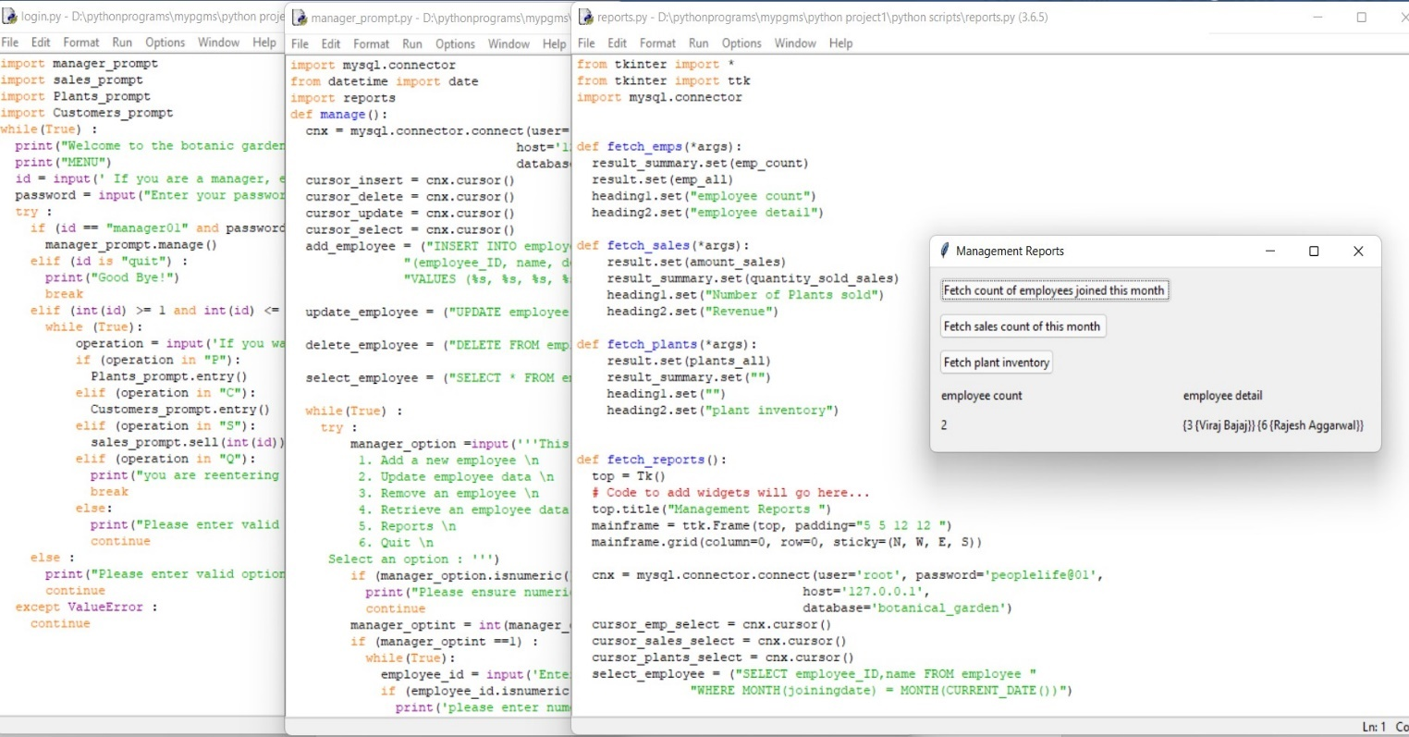

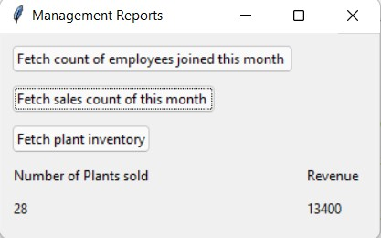

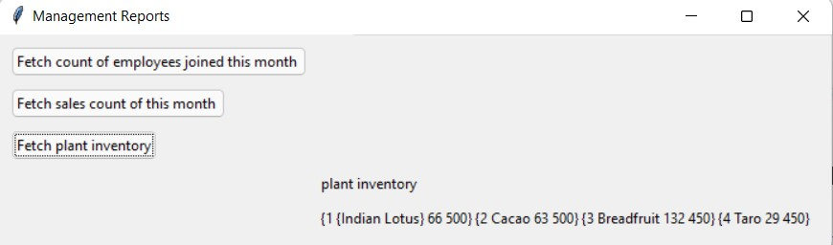

Part 6- Quit (Helps returning to the login menu)

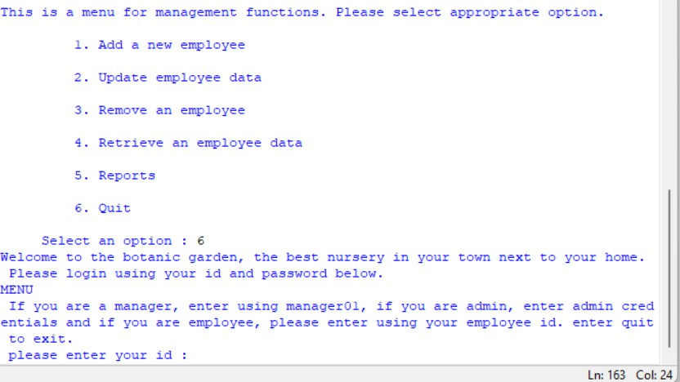

3. Other logins (admin, employee, caretaker and customers)

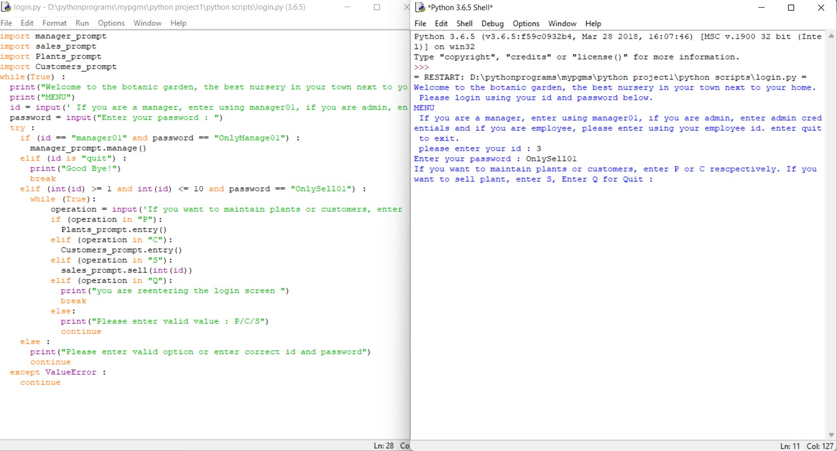

Part A – Maintaining plants data

Option 1 – Helps adding a new plant’s data.

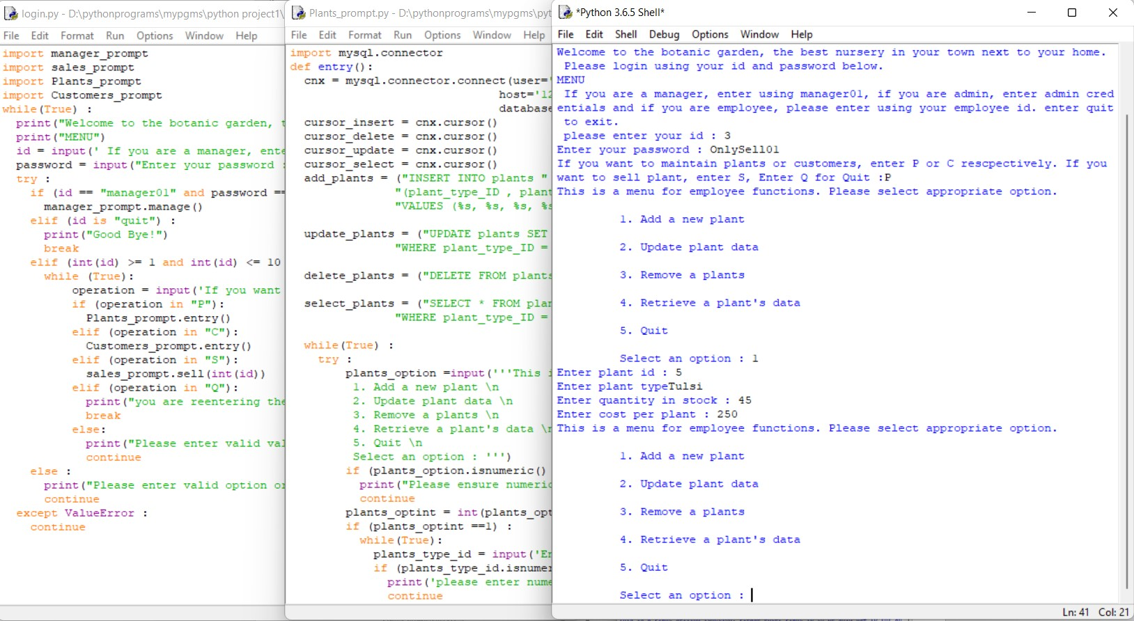

Option 2 and Option 3 – Help updating and removing plant data from the database respectively.

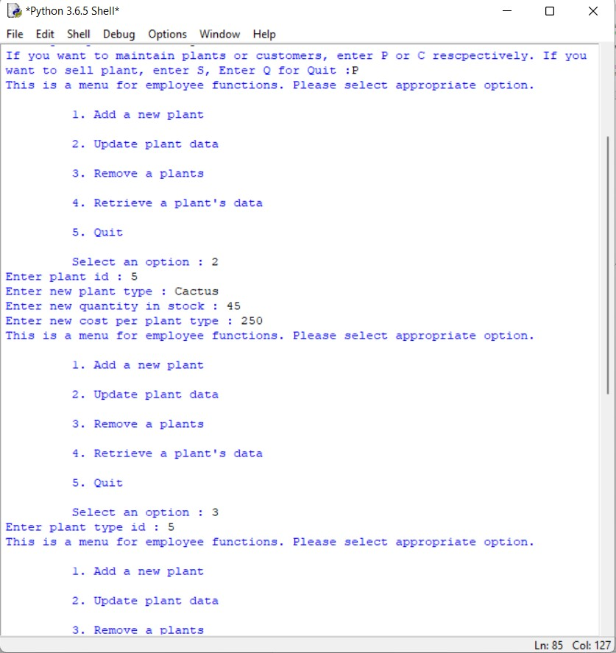

Option 4 and Option 5 – Help retrieving plant data and exiting the plant_prompt portal respectively

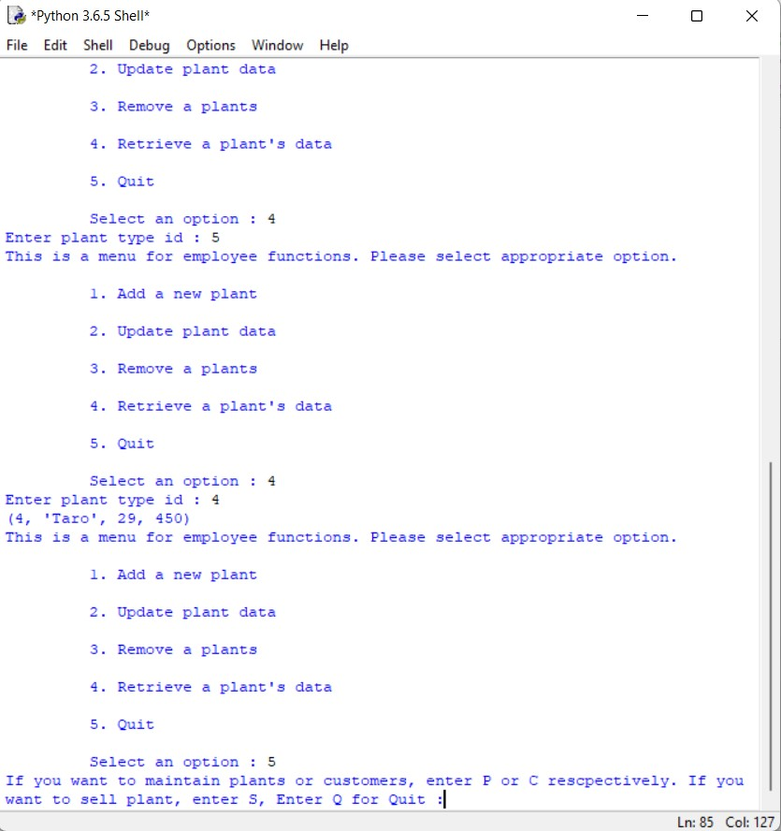

Part B – Maintaining customer data

Option 1 – Helps adding new customer’s data.

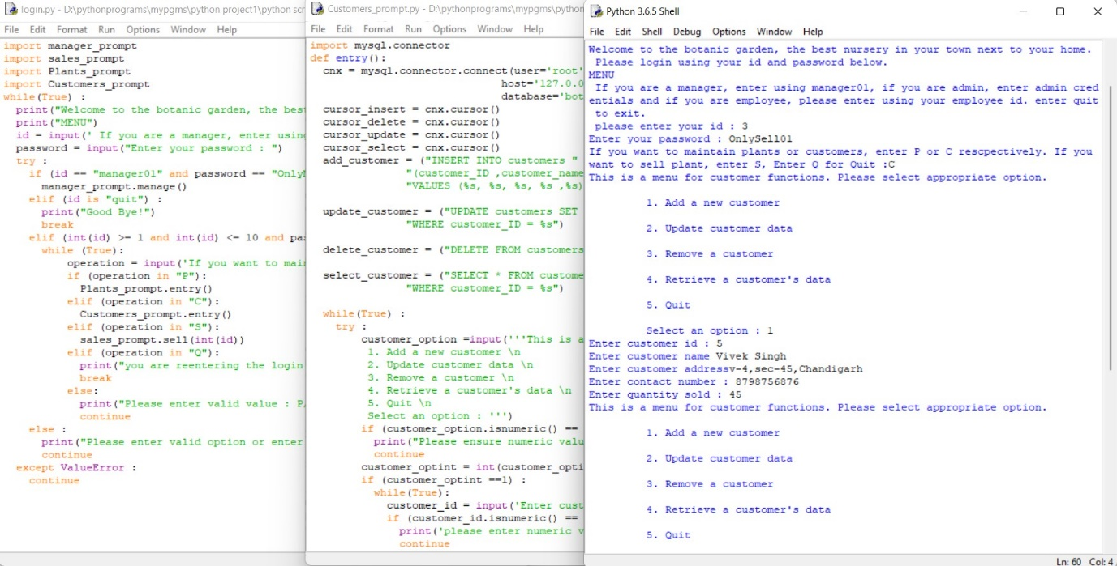

Option 2 and 3 – Help updating and removing customer data respectively.

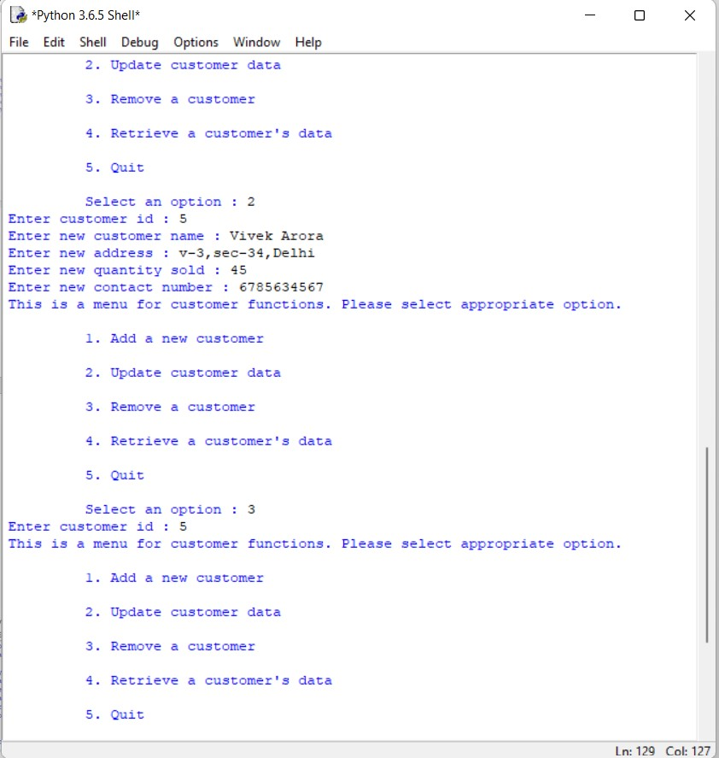

Option 4 and 5 – Help in retrieving customer data and existing the customer_prompt portal.

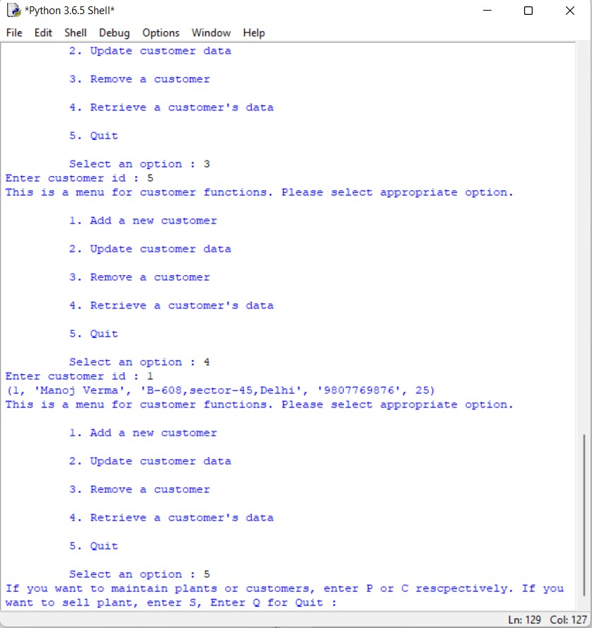

Part C – Maintaining Sales data

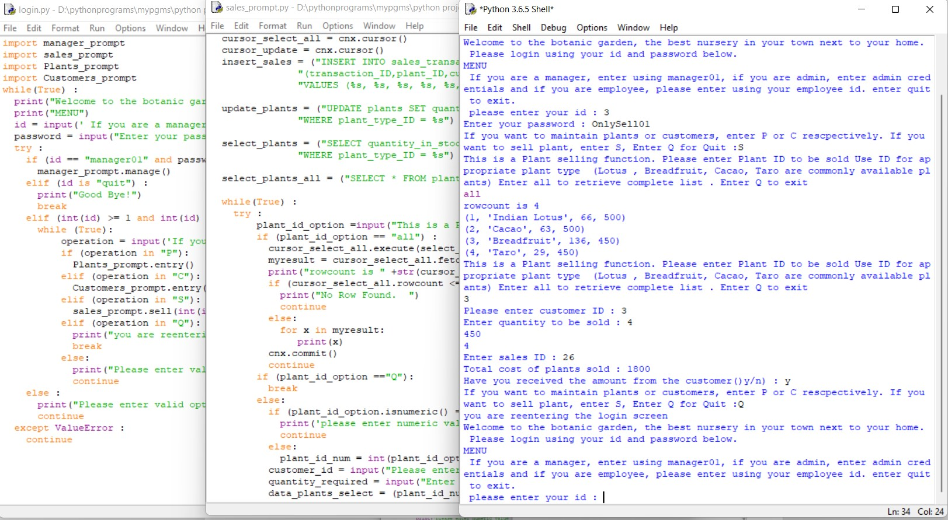

The updated data is also tracked in the csv file if amount received is ‘y’ - Transation.csv.

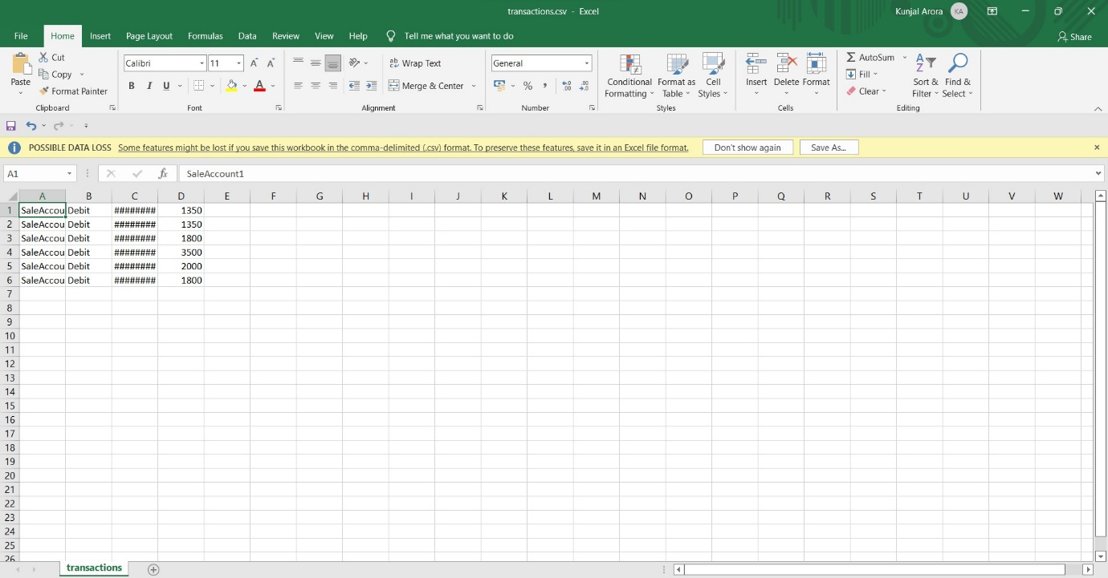

**Changes made are visible in the database**

